Jewish Artist Lab June 15, 2021
שבירות ושלימות
Brokenness and Wholeness
Our Interpretations

כמה ערך יש בדרך
kama erekh yesh baderkh
How much value there is in traveling along the road!

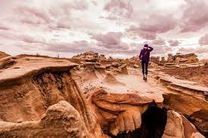

A Blessing for Healing
May the One who blessed our ancestors —
Patriarchs Abraham, Isaac, and Jacob,
Matriarchs Sarah, Rebecca, Rachel, and Leah —
bless and heal the one who is ill:
May the Holy Blessed One
overflow with compassion upon him/her,
to restore him/her,
to heal him/her,
to strengthen him/her,
to enliven him/her.
The One will send him/her, speedily,
a complete healing —רפואה שלימה
healing of the soul and healing of the body —
along with all the ill,
among the people of Israel and all humankind,
soon,
speedily,
without delay,
and let us all say: Amen!

May the work of your hands and hearts bring healing and wholeness to others.

